LAB 6
AWS Academy Cloud Foundations
Module 5 – Networking and Content Delivery
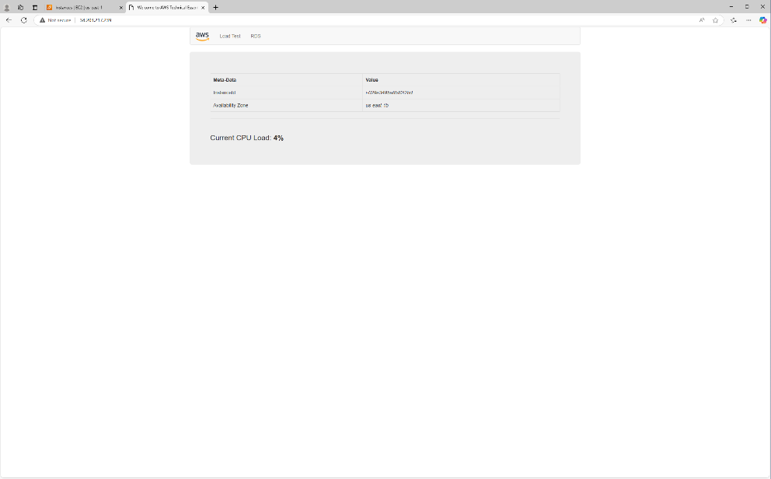
Lab 2 Build your VPC and Launch a Web Server

AWS Academy Cloud Operations
Module 7 - Networking
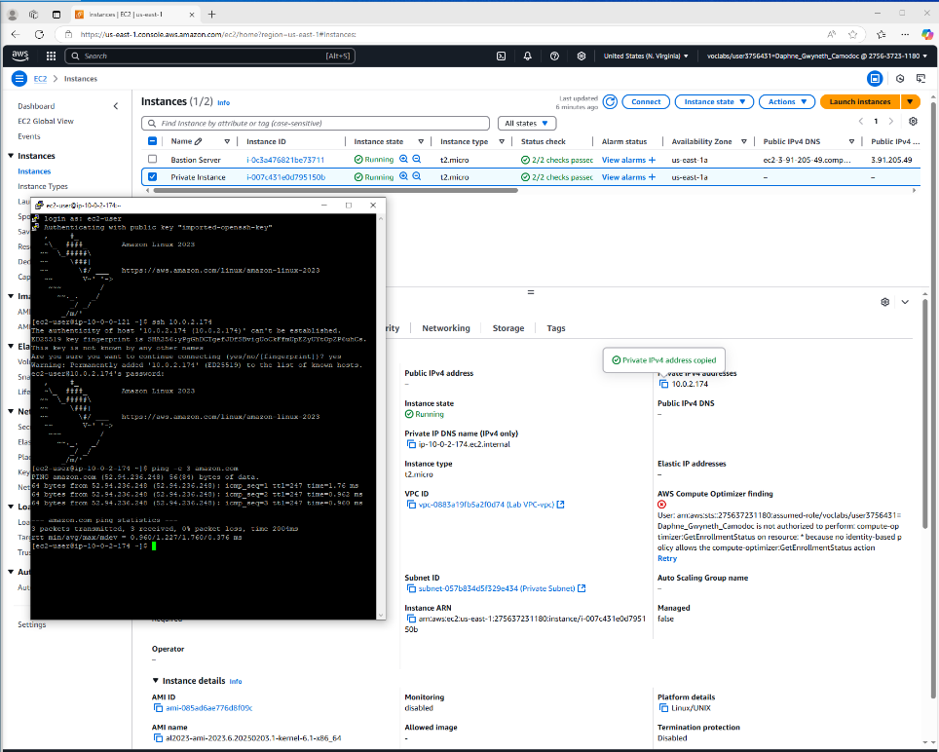
Lab 4 Configure VPC

